Document A
Letter to the Customs at Boston
(Transcription modified for length and clarity.)
Thomas Rowe worked for the British Customs Service in Salem. He was accused of reporting Salem merchants for attempting to smuggle molasses by secretly removing it from a ship without paying the required duties (taxes). The following day he was attacked by a mob of Salem residents, including. Richard Derby, his son Elias Hasket, and Salem merchant, George Crowninshield.

Page 1
Gentlemen,
The Collector was informed this morning that Captain Phillip Sanders of the Schooner Neptune recently arrived from Guadeloupe (French colony) & St. Eustatius (Dutch colony). Last evening, when the Waiter stepped home to see his wife, the ship hatches were opened, and casks of molasses were taken out. This was stopped from proceeding any further, by the Waiter’s return with the landwaiter. The Collector Comptroller Surveyor thought it proper this morning to visit the wharf where the vessel lay and inspect into the matter. There they found themselves
Page 2
surrounded by a large mob with a flag flying. The mob was in pursuit of the person who had given the information about the landing of said molasses. They continued to be very riotous for some time. But upon declaration of Mr. Savage, the Landwaiter, that he was totally ignorant of who the informer was, they went off. The officers, not thinking it prudent, for their own safety, to examine any further at that time as to the landing of the molasses, came up to the Custom House. Whilst they were attending their duty, they were alarmed by the appearance of the aforesaid mob, who had mounted in a hand-drawn cart, Thomas Rowe the Tide Waiter, who it seems they were told gave the first information to Mr. Savage. They had tarred his clothes all over, and then covered him with feathers, & pinned him into the cart, and were carrying him through the town as a spectacle of disgrace, stopping at all the Public Offices. When they came to the Custom House they were asked
Page 3
to release him, him being an Officer of the Customs and doing his duty. But they said they would not till they had done with him, the most they could be prevailed on to do was to promise they would not hurt him, and after carrying him to the edge of the town they released him, at the same time telling him he must not show his face again in this part.
Since this riot has subsided the captain and owners of Neptune have acknowledged that they landed nineteen casks of molasses in the night. They provided the said nineteen casks to the officers and have deposited them in a warehouse.

Page 4
The casks are not seized, we believing it our duty in this extraordinary affair to take no further steps without the direction of the Honorable Board.
We are with respect Gentlemen,
Your most obedient and faithful servants.
Signed: J. Fisher, Collector
John Mascarene, Comptroller
Customs of Salem & Marblehead
7th September 1768

Document A
Page 1 (See “Teacher Materials” for images of last three pages.)
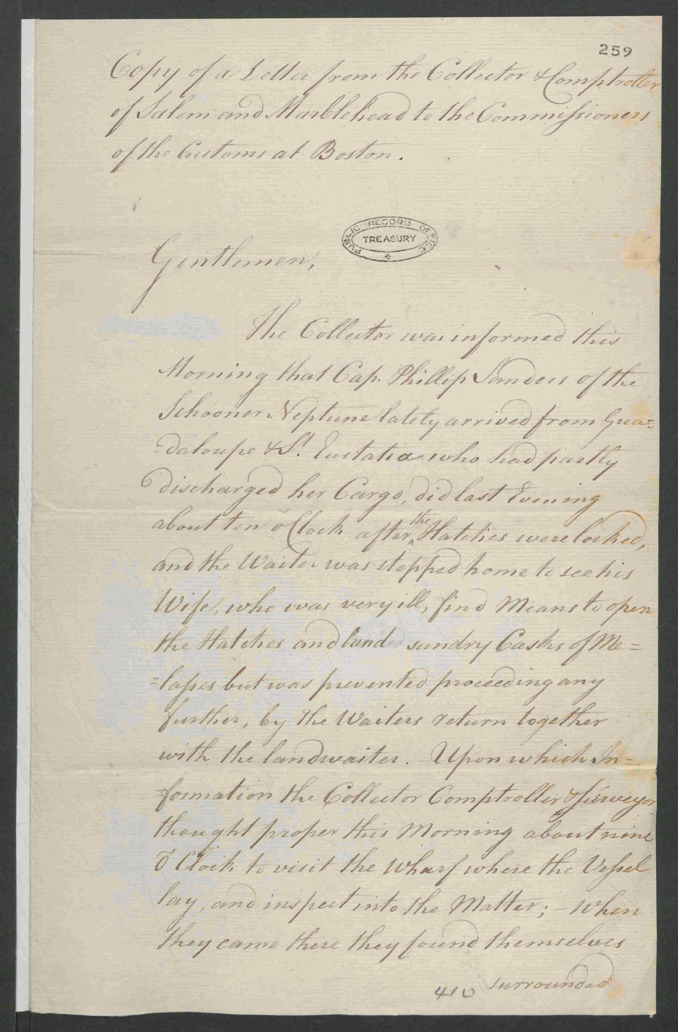

Image Source
The National Archives, United Kingdom. Copy of a Letter from the Collector & Comptroller of Salem and Marblehead to the Commissioners of the Customs at Boston. 1768 Sept. 7. T 1/465/259-260

Document B

Crowninshield Distilling Account with Richard Derby

Original Transcription
Richard Derby was a wealthy ship owner and merchant who traded and sold sugar and molasses from the West Indies. He also owned a Salem distillery where he used molasses to produce rum. This is an account of molasses (right side) used to produce rum (left side) for George Crowninshield, a Salem merchant and ship captain. Crowninshield may have exported this rum across the Atlantic Ocean to Europe or Africa, where it would be traded for enslaved people. It’s also possible he sold this rum locally or in other North American colonies. Note the bottom-left line, accounting for rum delivered by Crowninshield’s enslaved person.

Captain George Crowninshield his Distilling Account with Richard Derby
Left side
1765
December 13 Balance of former account in molasses…………………………………………………………………280 ¼
1766
July 19 10 gallons of rum, 1767 October 6, 33 ½ gallons of rum…………………….43 1/2
1770
August 17 17 ½ gallons rum delivered by W. Collins.…………………………………………..17 ½
32 ¾ gallons rum deliver by John Whitton………………………………………….32 ¾
22 14 hogshead rum equaling 111 gallons………………………………………………111
December 7 31 ¾ gallons of rum delivered by his servant……………………………………..31 ¾
22 30 hogshead rum equally 3300 gallons………………………………………………3300 3536 ½
3816 ¾
1771 January 31 ¾ gallons rum delivered by his Negro……………………………………………………………….31 ¾
3848 ½
Right side
1766
July 19 Sugar that made 10 gallons rum……………………………..10
1768
January 1 212 gallons of molasses of John Prince……………………212
1770
November 22 1 hogshead molasses equally 125 gallons……………….125
December 11 3300 gallons molasses…………………………………………….3300
3647

Vocabulary
- Hogshead: a type of barrel, a large round container used to package trade goods, like sugar, molasses, and rum.

Document B

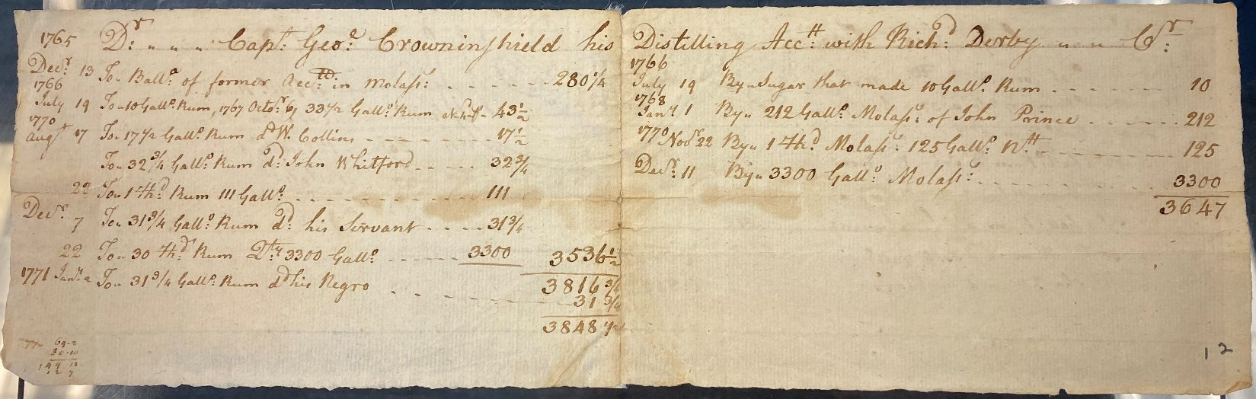

Image Source
MSS 37 Derby Family Papers, Box 16, Folder 1. Philips Library, Peabody Essex Museum, Salem, Mass. NPS Photo.

Graphic Organizer

 | Document A | Document B
#1
When and where was this document written?

#2
Who does the document mention?

#3
Who are they?

How are they (or their job) related to sugar?

Use background information and evidence for the documents to answer. | Salem Colonists (Including Richard Derby) | British Government & Customs Service Officers
#4
Context

How is sugar significant to this group?

#5
How did the Sugar Act affect people?

#6
How did they respond to the Sugar Act?

#7
How did the global slavery economy (business of slavery) contribute to the American Revolution in Salem?

